|  |  |  |  |  |  |  |
| --- | --- | --- | --- | --- | --- | --- |
| |  |  |  |  | | --- | --- | --- | --- | |  | | **MINISTRY OF EDUCATION AND TRAINING** | | | **FPT UNIVERSITY** | | |
| Capstone Project Document |
| Online Medical Consultant System |
| |  |  |  |  |  |  |  |  |  |  |  | | --- | --- | --- | --- | --- | --- | --- | --- | --- | --- | --- | | |  |  | | --- | --- | | **Group 02 – Report 04** | | | **Group member** | Trần Nguyên Tiến Sứ - Team Leader - SE60781  Trần Cao Danh - Team Member - SE60705 | | **Supervisor** | Mr. Nguyễn Huy Hùng | | **Ext. Supervisor** | N/A | | **Capstone Project code** | OMCS | | |
| * Ho Chi Minh City, 20 June / 2014 – |

Table of Contents

List of Tables 3

No table of figures entries found.List of Figures 3

Definitions, Acronyms, and Abbreviations 4

A. Report No.4: Software Design Description (SDD) 5

1. Design Overview 5

2. System Architectural Design 6

2.1 Choice of system architecture 6

3. Component Diagram 7

4. Detailed Description of Components 8

4.1 Class Diagram 8

5. Sequence Diagram 9

5.1 <Guest> Login 9

5.2 <Guest> Register 9

5.3 <Authorized User> Change Password 10

5.4 <Authorized User> Change Profile Picture 11

5.5 <Patient> Conversation 11

5.6 <Doctor> Request Webcam 12

5.7 <Patient> Show Webcam 12

5.8 <Patient> Upload Attachment 13

5.9 <Admin> Define New Medical Profile Template 13

5.10 <Admin> Update Medical Profile Template 14

5.11 <Doctor> Update Medical Profile 14

5.12 <Doctor> Views Medical Profile 16

5.13 <Patient> Update Personal Health Record 16

5.14 <Patient> View medical Profile Record 17

6. Database Design 17

# List of Tables

# No table of figures entries found.List of Figures

Figure 1: MVC Architecture 6

Figure 2: Component Diagram 7

Figure 3: Class Diagram 8

Figure 4: <Guest> Login Sequence Diagram 9

Figure 5: <Guest> Register Sequence Diagram 10

Figure 6: <Authorized User> Change Password Sequence Diagram 11

Figure 7: <Authorized User> Change Profile Picture Sequence Diagram 11

Figure 8: <Patient> Conversation Sequence Diagram 12

Figure 9: <Doctor> Request Webcam Sequence Diagram 12

Figure 10: <Patient> Show Webcam 13

Figure 11: <Patient> Upload Attachment 13

Figure 12: <Admin> Define New Medical Profile Template 14

Figure 13: <Doctor> Update Medical Profile 15

Figure 14: <Doctor> Views Medical Profile 16

Figure 15: <Patient> Update Personal Health Record 16

# Definitions, Acronyms, and Abbreviations

# 

# Report No.4: Software Design Description (SDD)

## Design Overview

* This document describes the technical and user interface design of. It includes the architectural design, the detailed design of common functions and business functions and the design of database model.
* The architectural design describes the overall architecture of the system and the architecture of each main component.
* The detailed design describes static and dynamic structure for each component and functions. It includes class diagrams, class explanations and sequence diagrams for each use cases.
* The database design describes the relationships between entities and details of each entity.

## System Architectural Design

### Choice of system architecture

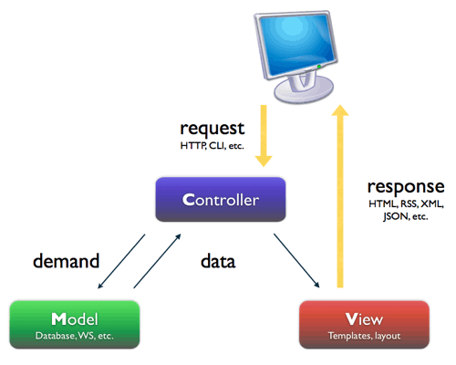

Figure 1: MVC Architecture

**(http://smist08.wordpress.com/tag/mvc/)**

**The Model** is the part of the application that handles the logic for the application data.  
Often model objects retrieve data (and store data) from a database.

**The View** is the parts of the application that handles the display of the data.  
Most often the views are created from the model data.

**The Controller** is the part of the application that handles user interaction.  
Typically controllers read data from a view, control user input, and send input data to the model.

**(**<http://www.w3schools.com/aspnet/mvc_intro.asp>**)**

## Component Diagram

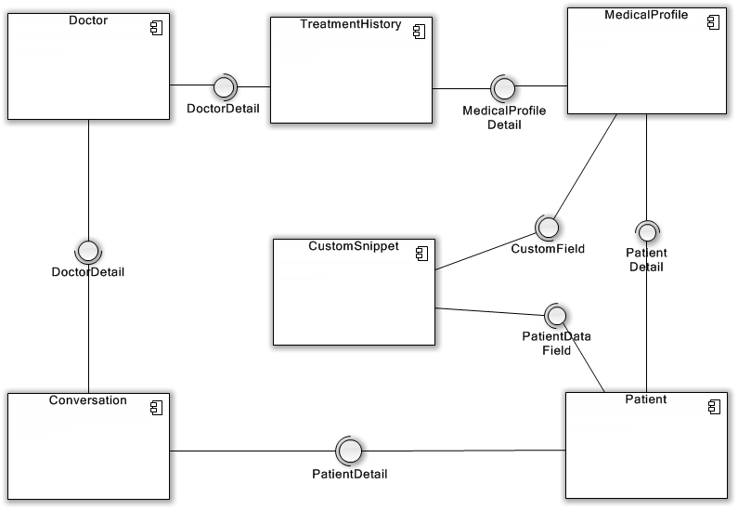

Figure 2: Component Diagram

## Detailed Description of Components

### Class Diagram

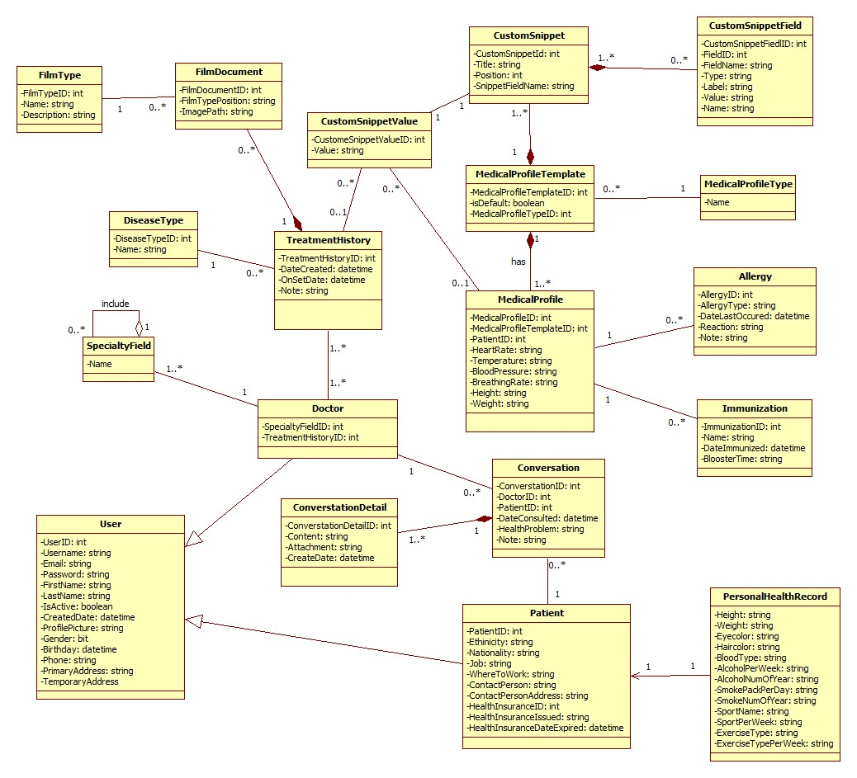

Figure 3: Class Diagram

## Sequence Diagram

### <Guest> Login

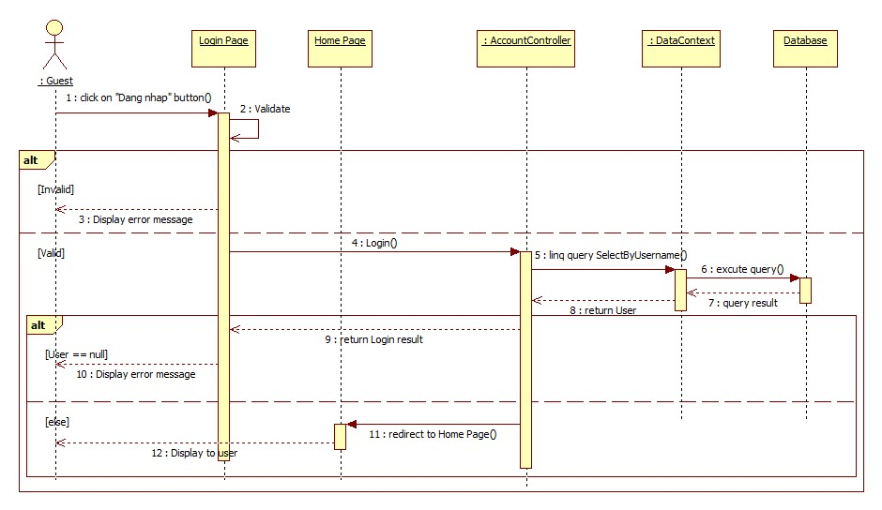

Figure 4: <Guest> Login Sequence Diagram

### <Guest> Register

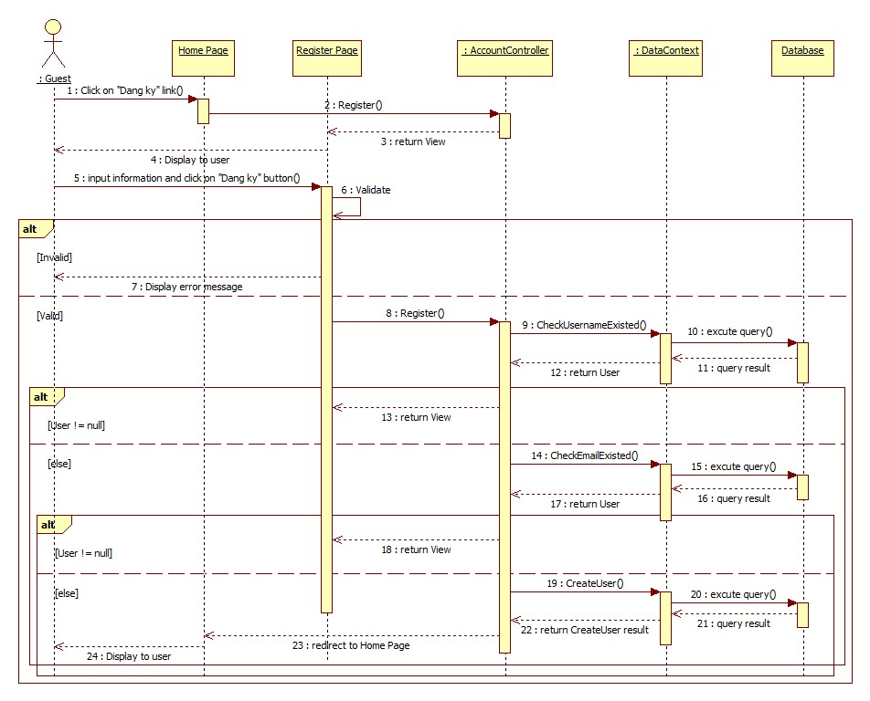

Figure 5: <Guest> Register Sequence Diagram

### <Authorized User> Change Password

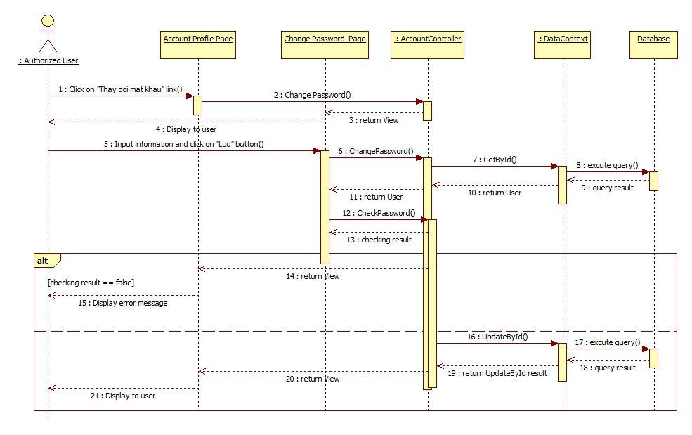

Figure 6: <Authorized User> Change Password Sequence Diagram

### <Authorized User> Change Profile Picture

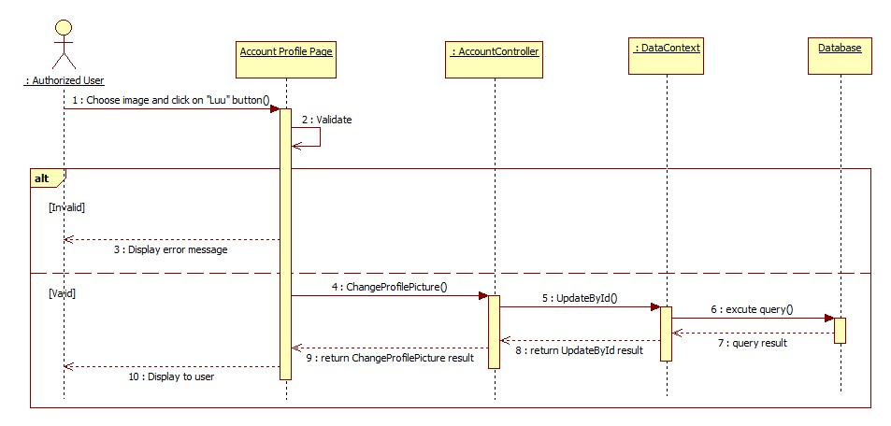

Figure 7: <Authorized User> Change Profile Picture Sequence Diagram

### <Patient> Conversation

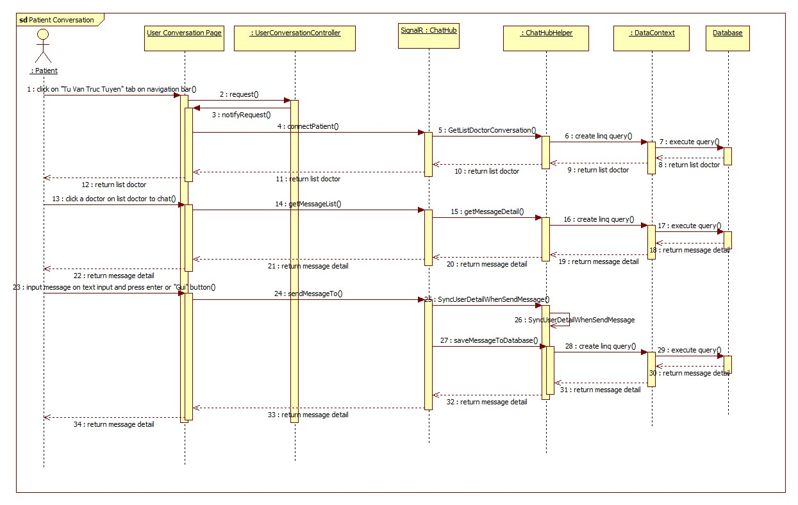

Figure 8: <Patient> Conversation Sequence Diagram

### <Doctor> Request Webcam

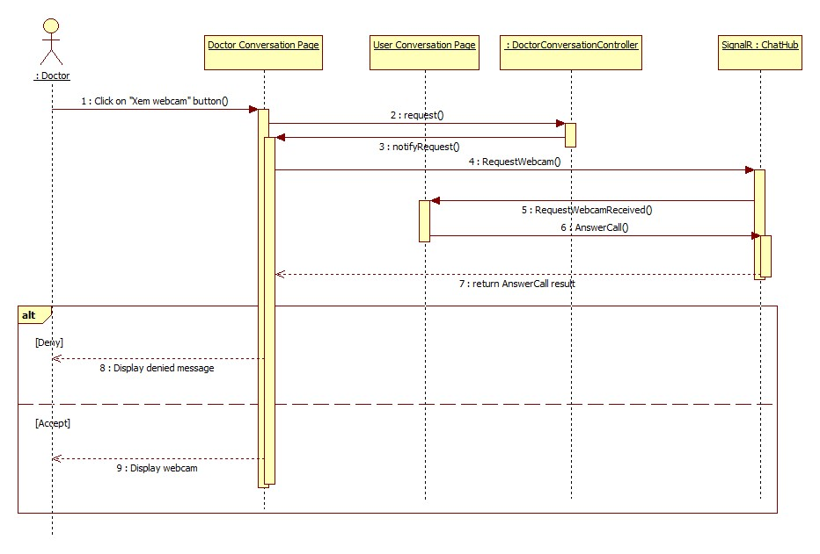

Figure 9: <Doctor> Request Webcam Sequence Diagram

### <Patient> Show Webcam

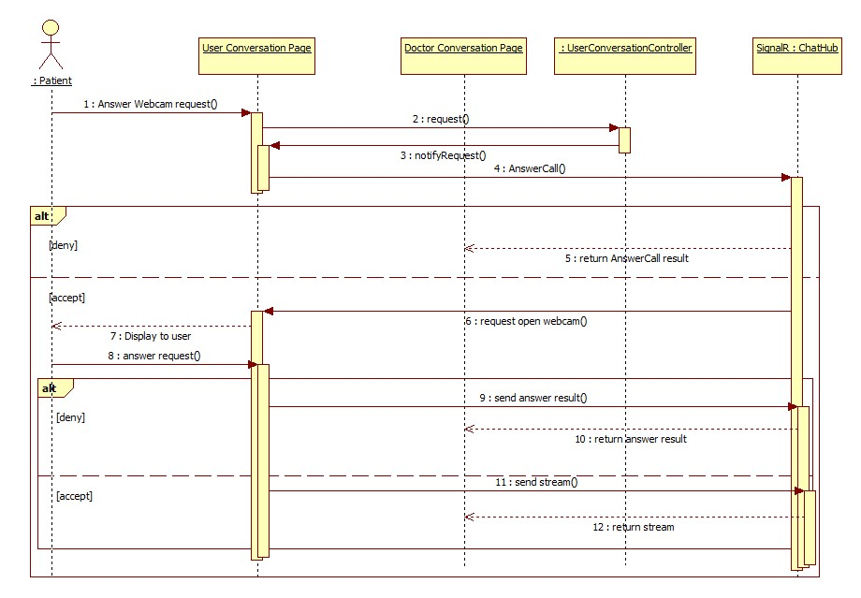

Figure 10: <Patient> Show Webcam

### <Patient> Upload Attachment

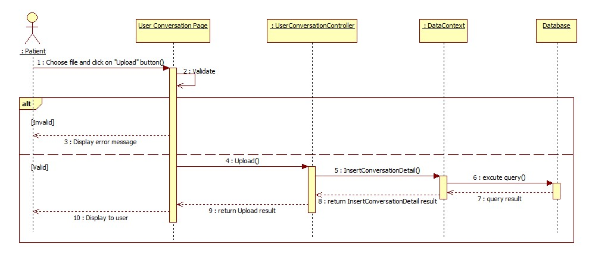

Figure 11: <Patient> Upload Attachment

### <Admin> Define New Medical Profile Template

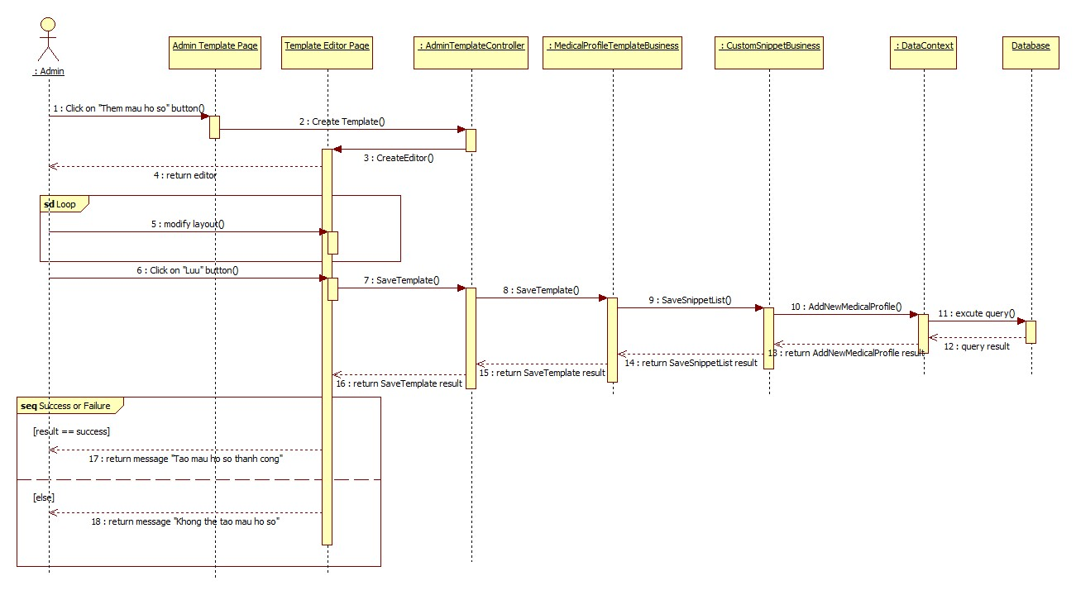

Figure 12: <Admin> Define New Medical Profile Template

### <Admin> Update Medical Profile Template

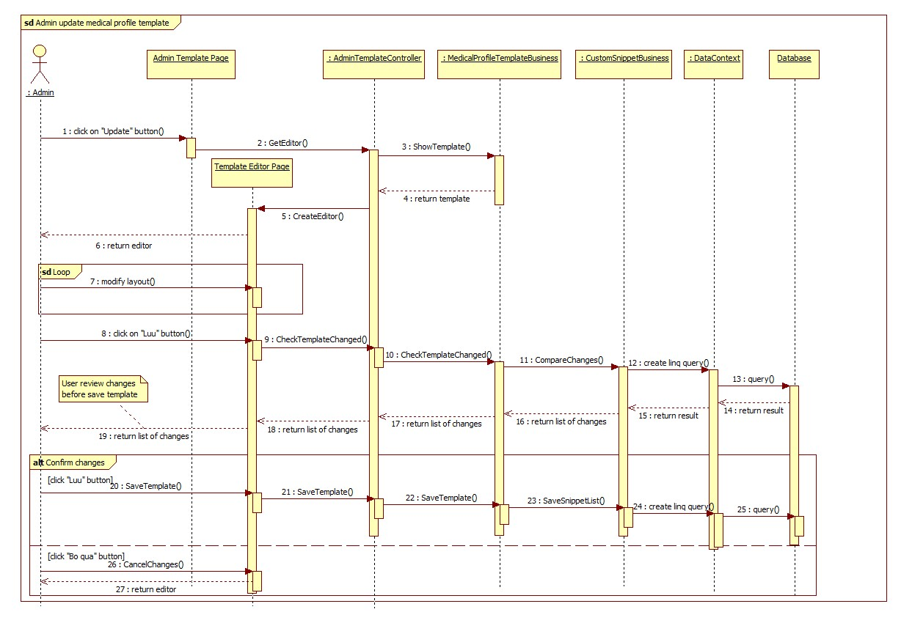

### <Doctor> Update Medical Profile

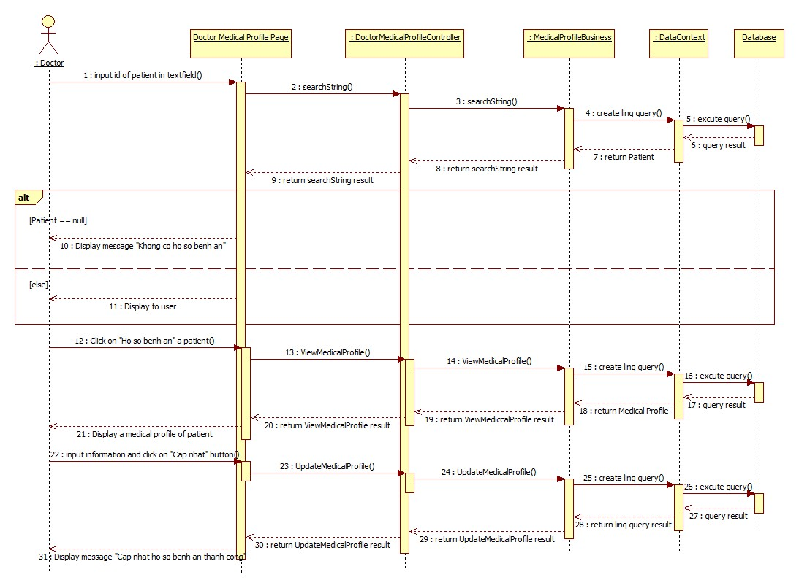

Figure 13: <Doctor> Update Medical Profile

### <Doctor> Views Medical Profile

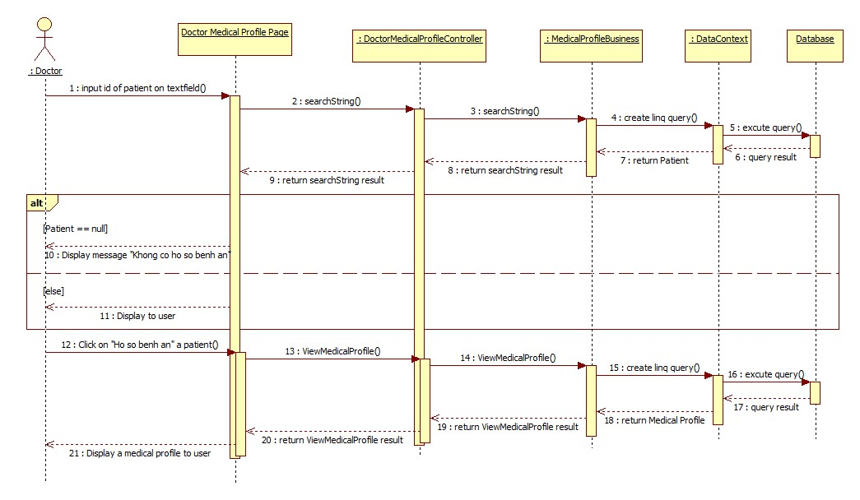

Figure 14: <Doctor> Views Medical Profile

### <Patient> Update Personal Health Record

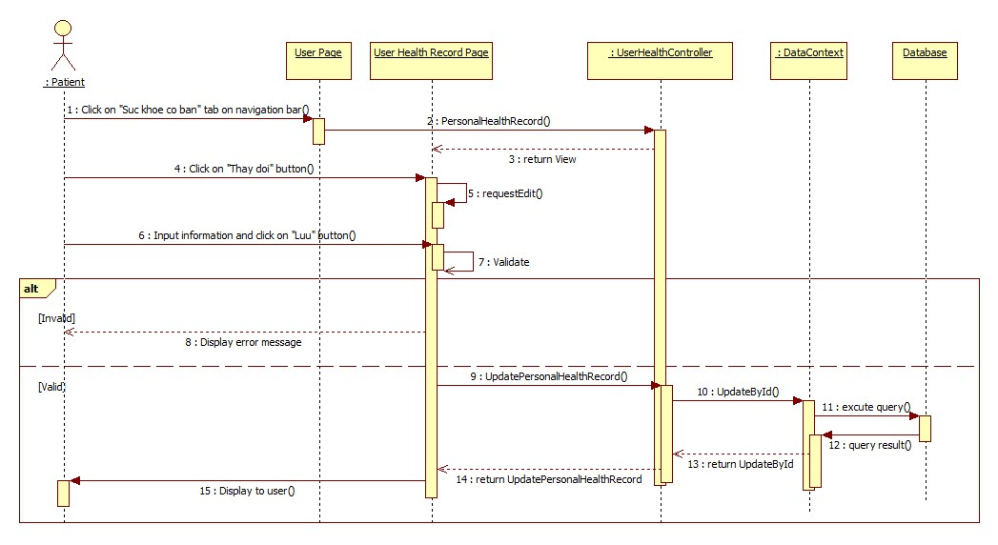

Figure 15: <Patient> Update Personal Health Record

### <Patient> View medical Profile Record

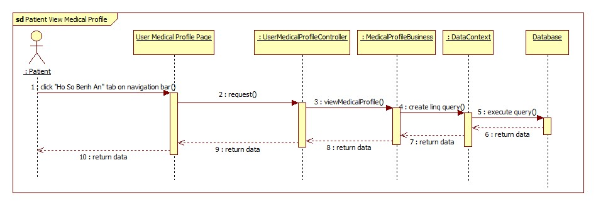

Figure 9: <Patient> View Medical Profile Record

## Database Design

